ULTRA SONIC SENSOR

An ultrasonic sensor is an instrument that measures the distance to an object using ultrasonic sound waves.

An ultrasonic sensor uses a transducer to send and receive ultrasonic pulses that relay back information about an object’s proximity.

# How Ultrasonic Sensors Work.

Ultrasonic sound vibrates at a frequency above the range of human hearing.

Transducers are the microphones used to receive and send the ultrasonic sound.

Our [ultrasonic sensors](https://www.maxbotix.com/SelectionGuide/Selection-Guide.htm), like many others, use a single transducer to send a pulse and to receive the echo.  The sensor determines the distance to a target by measuring time lapses between the sending and receiving of the ultrasonic pulse.

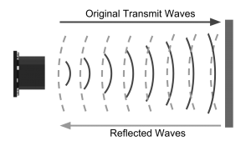

The working principle of this module is simple.  It sends an ultrasonic pulse out at 40kHz which travels through the air and if there is an obstacle or object, it will bounce back to the sensor.  By calculating the travel time and the speed of sound, the distance can be calculated.

# Why use an Ultrasonic Sensor?

Ultrasound is reliable in any lighting environment and can be used inside or outside.  Ultrasonic sensors can handle collision avoidance for a robot, and being moved often, as long as it isn’t too fast.

Ultrasonics are so widely used, they can be reliably implemented in grain bin sensing applications, water level sensing, drone applications and sensing cars at your local drive-thru restaurant or bank.

Ultrasonic rangefinders are commonly used as devices to detect a collision.

### Ultrasonic Sensors are best used in the non-contact detection of:

* Presence
* Level
* Position
* Distance

*Non-contact sensors are also referred to as****proximity sensors.***

### Ultrasonics are Independent of:

* Light
* Smoke
* Dust
* Color
* Material (except for soft surfaces, i.e. wool, because the surface absorbs the ultrasonic sound wave and doesn’t reflect sound.)

***Long range detection****of targets with varied surface properties.*

[Ultrasonic sensors are superior to infrared sensors](https://www.maxbotix.com/articles/ultrasonic-or-infrared-sensors.htm) because they aren’t affected by smoke or black materials, however, soft materials which don’t reflect the sonar (ultrasonic) waves very well may cause issues. It’s not a perfect system, but it’s good and reliable.

# Applications Involving Ultrasonic Detection:

### **Ultrasonic Distance Measurement**

Distance measurement is based on the measurement of time-of-flight.  The time between sending and receiving the reflected sound signal is calculated by the sensor.  *Ultrasonic distance sensors*, like the [MB7360 HRXL-MaxSonar-WR](https://www.maxbotix.com/Ultrasonic_Sensors/MB7360.htm), are used in as height monitors, bin level measurement and proximity zone detect.

* + - *Ex. Distance measurement would be applied in a*[*garage parking application*](http://www.plasmacomp.com/blogs/benefits-of-smart-parking-solution)*, sensing when a vehicle is pulled completely into a garage.*

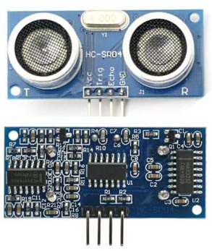

CONNECTING ULTRASONIC SENSOR WITH NODEMCU..

## **Technical Specifications**

* Power Supply − +5V DC
* Quiescent Current − <2mA
* Working Current − 15mA
* Effectual Angle − <15°
* Ranging Distance − 2cm – 400 cm/1″ – 13ft
* Resolution − 0.3 cm
* Measuring Angle − 30 degree

## **Components Required**

You will need the following components −

* 1 × Breadboard
* 1 × Arduino Uno R3
* 1 × ULTRASONIC Sensor (HC-SR04)

**HOW IT WORKS?**

We have to figure out the distance because the sensor itself simply holds it's "ECHO" pin HIGH for a duration of time corresponding to the time it took to receive the reflection (echo) from a wave it sent.

1. The module sends out a burst of sound waves, at the same time it applies voltage to the echo pin.
2. The module receives the reflection back from the sound waves and removes voltage from the echo pin.

On the base of the distance a pulse is generated in the ultrasonic sensor to send the data to NodeMCU or any other micro-controller.

The starting pulse is about 10us and the PWM signal will be 150 us-25us on the base of the distance. If no obstacle is there, then a 38us pulse is generated for NodeMCU to confirm that there are not objects detected.

Before getting the reading of the HC-SR04 know about the calculation.

**FORMULA**

**D = 1/2 × T × C**

where D is the distance, T is the time between the Emission and Reception, and C is the sonic speed.

(The value is multiplied by 1/2 because T is the time for go-and-return distance.)

CODE

#define TRIGGER 13

#define ECHO 14

void setup() {

pinMode(TRIGGER, OUTPUT); // Sets the TRIGGER as an Output

pinMode(ECHO, INPUT); // Sets the ECHO as an Input

Serial.begin(9600); // Open serial channel at 9600 baud rate

}

void loop() {

long duration;

int distance;

digitalWrite(TRIGGER, LOW);

delayMicroseconds(2);

digitalWrite(TRIGGER, HIGH);

delayMicroseconds(10);

digitalWrite(TRIGGER, LOW);

duration = pulseIn(ECHO, HIGH);

distance= duration*0.034/2; Serial.print("Distance = "); //Output distance on arduino serial monitor

Serial.println(distance);

delay(3000); //Pause for 3 seconds and start measuring distance again

}

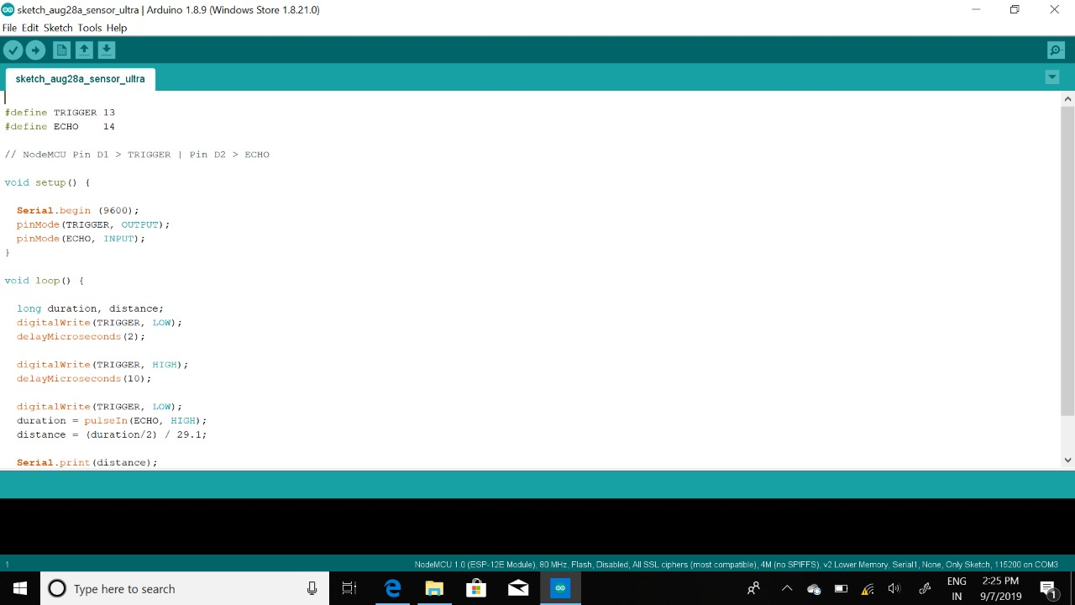CONNECTIONS: 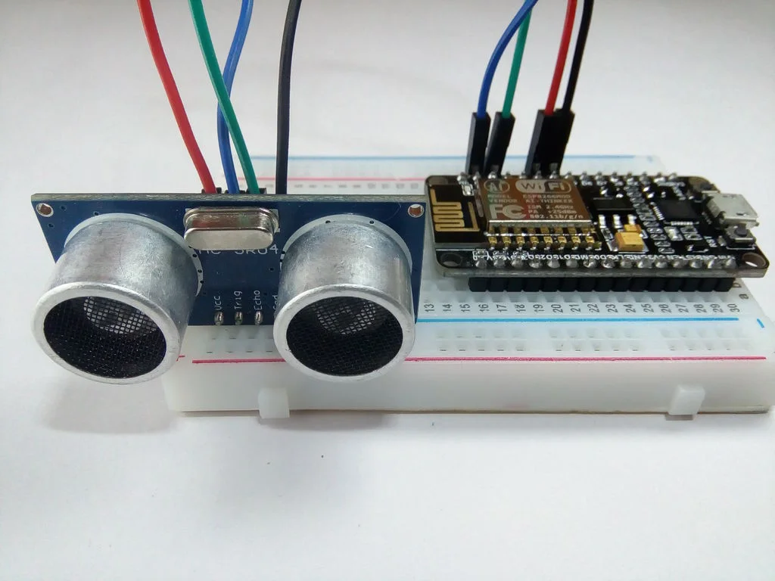

REGARDS:

NARSIMHA REDDY

DHEERAJ T

RAGASRI YARLAGADDA